Baby Monitor Project Report

CITS 5506 The Internet of Things

Team members:
Le Zhang (21656304)
Spandana Vadde (21779055)
Keyur Modi (21845191)

Project Scope
This baby monitor project is to create an Internet of Things (IoT) based baby monitoring device that helps parents or kindergarten teachers to monitor the sleeping status of babies and trigger an alert when a baby cry and movement are detected together. The device will then send an alert message to the parents or teachers Facebook messenger application through a web server.

Background and Justification
There are quite a few baby monitors in the market, a portion of which are web cameras that require constant checking to make sure the baby is sleeping sound because they seldom have any alert mechanism that is designed specifically for babies. There are other kinds of baby sound detectors that are either transferring sound directly or only can detect baby cry but not motion. Our project combines a PIR (Pyroelectric “Passive” InfraRed Sensor) motion sensors with the sound detection to largely eliminate the chance of false alarms. Furthermore, it utilizes Facebook messenger application which has been widely used by many people, to send the alert in a user-friendly way with good accessibility. It frees parents from constant checks on the babies when they are asleep, so they can utilize the time to go grocery shopping or do other activities near their homes and can get back when a notification is sent to their cell phones.

System Architecture
The whole system consists of a baby monitor, movement sensor, a web server and mobile application as show in the diagram below.
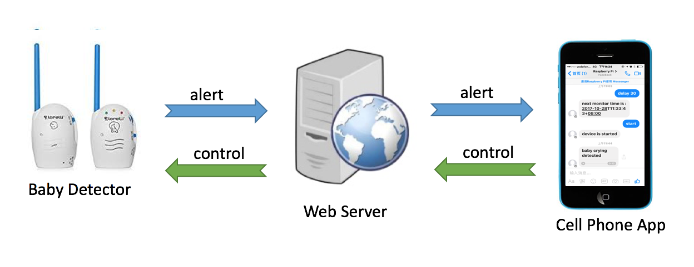
Figure 3-1. Baby monitor system architecture.

The baby monitor detects baby motion and baby cry sound. When a baby cry event is detected, it will automatically start recording the subsequent sound for about 10 seconds, and then it sends an alert together with the sound message (in .wav format) to a web server with it's device id, as shown in figure3-2 below. The web server stores the information of the registered user and uses the device id to find the stored Facebook id of that user, then send using Facebook chat API to the messenger application on the registered user's mobile device. The end user, on the other hand, has functionality to reply with instructions to control the monitor device, simple instruction like "stop", "start" is acceptable to control the start, end or stop of the detection, and the user can also tell the monitor to delay monitoring for 30 minutes in case he/she doesn't want to be disturbed for the next 30 minutes by simply send "delay 30". Thus for next 30 minutes, the user won't be notified about any baby's motion detection and cry sound.
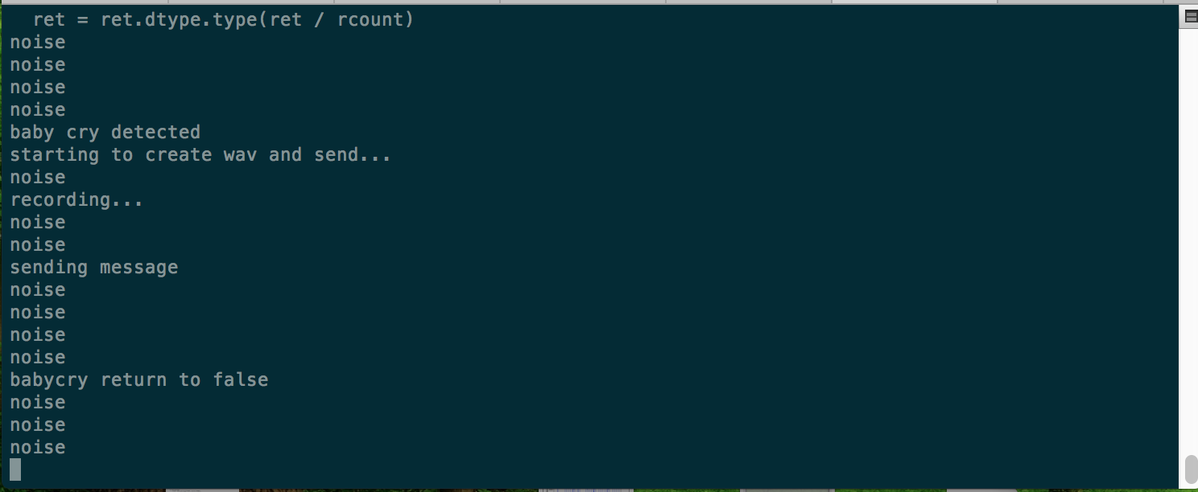
Figure 3-2. Baby cry detection output
Hardware components of baby detector include:
Items | Item Description | Quantity
PIR Sensor | Passive infrared sensor  to detect motion | 1
LED | Indication of alert or status | 3
Switch | Start or stop monitor | 1
Cables | For connection | several
Raspberry Pi 3 | Main control board | 1
USB microphone | Pluggable microphone to detect sound | 1
Bread Board | For Connection | 1
Table 3-1. Hardware components
The system board connections are as shown below:

Figure 3-3. System board
The PIR sensor and USB microphone are used to detect motion and baby cry sound respectively, the switch is used to start or stop the detector, so the alerts are not detected and sent, users can also control the start, stop and delay from remote using Facebook messenger application.
The three LEDs show the status of the detector; they indicate events as shown in below table:
LED | Lit Mode | Indications
Red LED | Constant Lit | Internal Errors(program errors)
Red LED | Slow Blink | No Wi-Fi connection
Green LED | Constant Lit | Normal Monitoring
Green LED | Slow Blink | Standby/Stopped
White LED | Blink | Baby Cry Detected

Table 3-2. Indications of LEDs

Software Mechanisms of the System

Baby Monitor
Motion Detection
The PIR sensor detects levels of infrared radiation, when a change of the ambient infrared levels is detected, the output pin of the sensor will go "high" to 3.3V, so the software is programed to capture the signal to detect a motion.

Baby Cry Detection
The baby cry detection part is trickier, the aim is to capture the characteristics of the amplitude and frequency of baby cry in order to differentiate it from the noise and background sound. According to the research found that the frequency of a baby's crying voice measures in at about between 1,000 Hz and 5,000 Hz and centered at 3500 Hz, which provides us a valuable clue to make it detectable. Although there are other more sophisticated methods like Fast Fourier Transform (FFT) or even Convolutional Neural Network (CNN) that can be used to analyze and "learn" sound signals, they are often at a cost of higher computational power and takes more time. Due to the natural efficiency required by our project to analyze real-time sound frames, we choose to use a much simpler and efficient method called Zero Crossing to calculate the frequency of each sound stream chunk. And we used the absolute average amplitude value to represent the amplitude of that chunk.
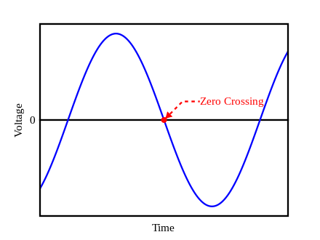
Figure 4-1. Zero Crossing Frequency graph
We used python library pyaudio to read each chunk from the sound source (our USB microphone). Following is a picture showing the captured frequency and amplitude with time, a frequency is shown in blue line, and an amplitude is an orange line. We should note that the frequency is just the number of zero crossings of each chunk, not in the unit of hertz, and the time is represented by the number of chunks. But these don't affect our aim to differentiate baby cry sound from other sounds.
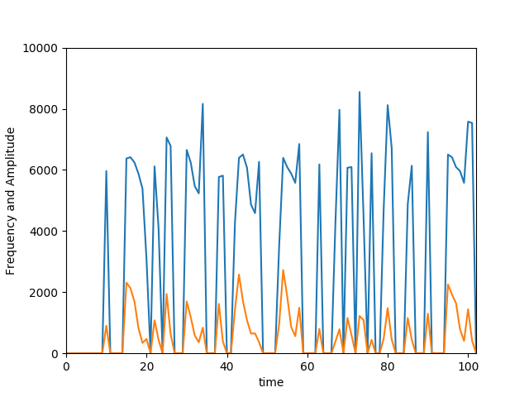
Figure 4-2. Frequency and Amplitude with Time graph
And since the time frame of a chunk (1024) is too small (only about 1/43 second for 44100hz sound samples), so we are using 100 chunks (little more than 2 seconds) as a window of analysis for the overall pattern. Through further comparisons made between baby cry samples and other noise, we have found that not all the points in a window are needed, the peaks are representative enough of the whole window.
So we used a python library to detect the peaks of each window.
Following diagrams compare the peaks of baby cry sound and other noises, the mph means we select peaks that are over 1000 in frequency, and mpd means the minimum distance between each peak, note that the "Amplitude" label of y-axis actually represents frequency. From this comparison we can get the general direction for our mechanism to filter out baby cry:
The characteristics of baby cry:
- The average frequency of the peaks in a window is between 2000 to 3000
- The standard deviation is smaller than other noises, less than 1000
- The average amplitude should be over 20, because babies won't be too quiet when they cry.
- The number of peaks in a window are between 3 to 14, too many peaks are unnatural for a baby and too few may indicate a chance hit.
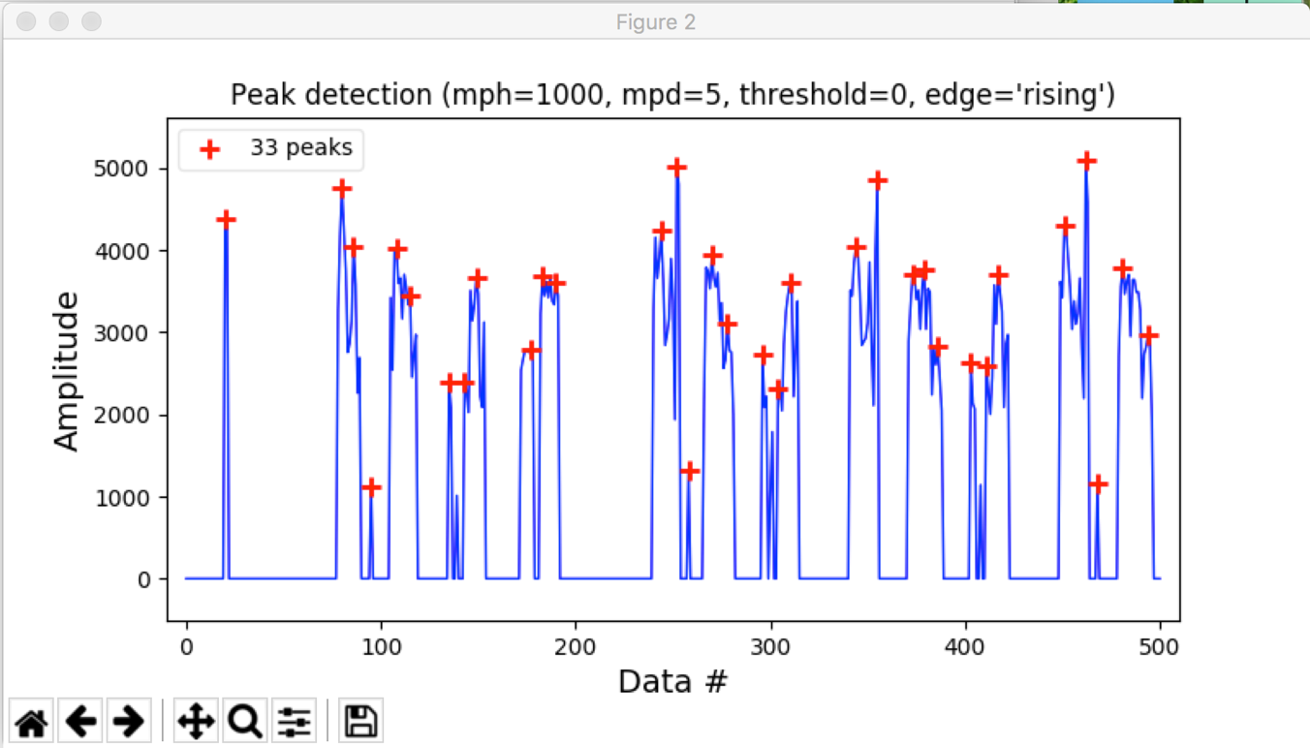
Figure 4-3. The peaks of baby cry samples

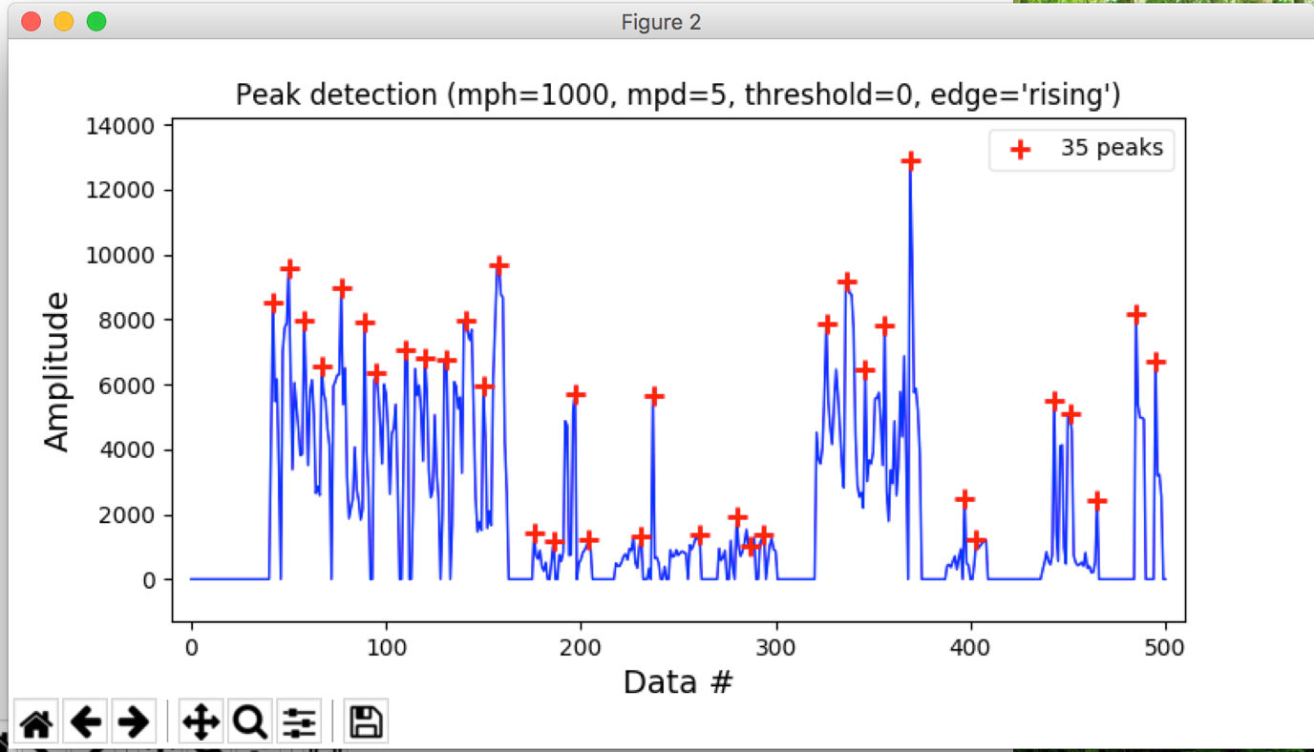
Figure 4-4. The peaks of other noises
Using these above mentioned traits from quite a few comparisons and analysis, we can design and calibrate our detection model to detect a baby cry event.

Baby Sound Recording and Alerting:
When a baby cry event is detected, we are now focusing on confirming the authenticity. One of the best ways may be to send the sound to the user for confirmation. So we then decided to use the pyaudio library to record the subsequent sound frames and create a .wav file on a separate thread, so that monitoring process is not interrupted. And the generated sound file is uploaded to the web server through a post request.

Web server
Following is a screenshot of our web server. It plays a critical part in the baby monitor system to manage the communications between the user and the device.
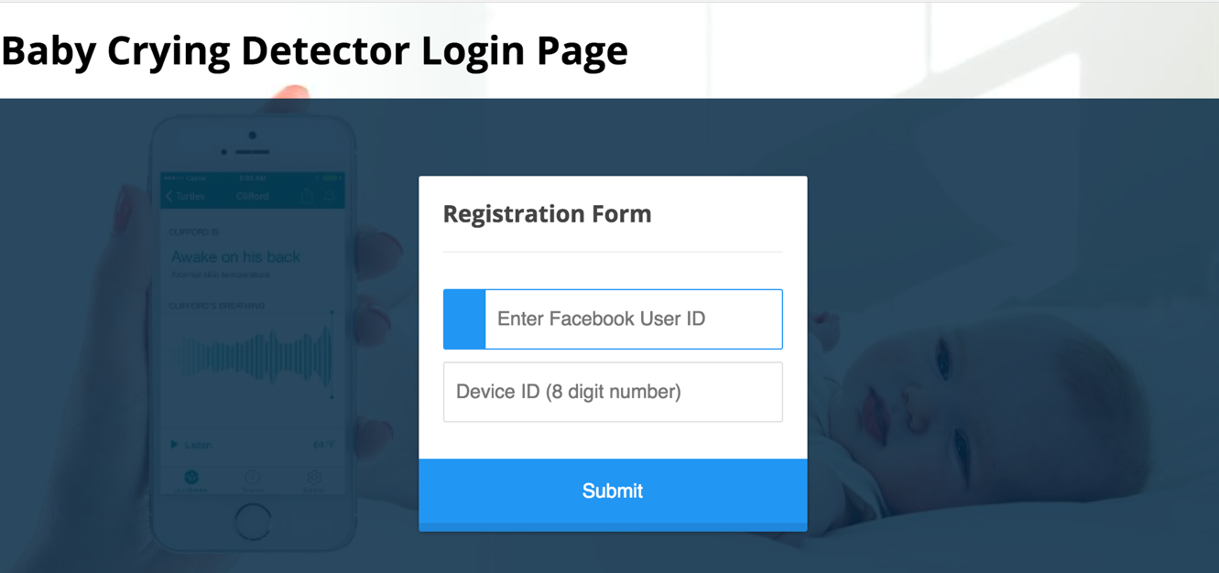
Figure 4-5. UI of login page
Our web server has following functionalities:
- Stores the Facebook user ids and baby detector device ids in mongo db.
- Manages the post requests of the uploaded baby cry sound from each detector.
- Manages a baby detector Facebook account that adds the registered users as friends, and send the alert message with the recorded sound through the facebook chat API to the user's facebook messenger, and listens to user's instructions sent using messenger.
- Stores the next monitor time for each device, and feedback to the constant query requests from each device.
The following chart illustrates the overall flow of how a web server communicates with each device and users' Facebook messenger applications:

Figure 4-6. shows the flow of web-server with users
The web server manages a MongoDB database and a Facebook account, when a user first registers the device and his Facebook user id from the baby minotor home page, the data get stored. Each device will check whether any user has registered with that device on start-up, if no record is found, the red led on the device will lit indicating an error. An alert message with a clip of recorded sound will be uploaded to the server if a cry event occurs, the server then checks the user id and sends the message to the specific user through it's Facebook account.
The user can also place instructions remotely by sending messages through the messenger, the server then stores the command in the database. The detector will constantly check the available command with the server and act on that command.

User Messenger App

We utilize Facebook messenger application as a media to alert user on the baby cry event and also accept user command.

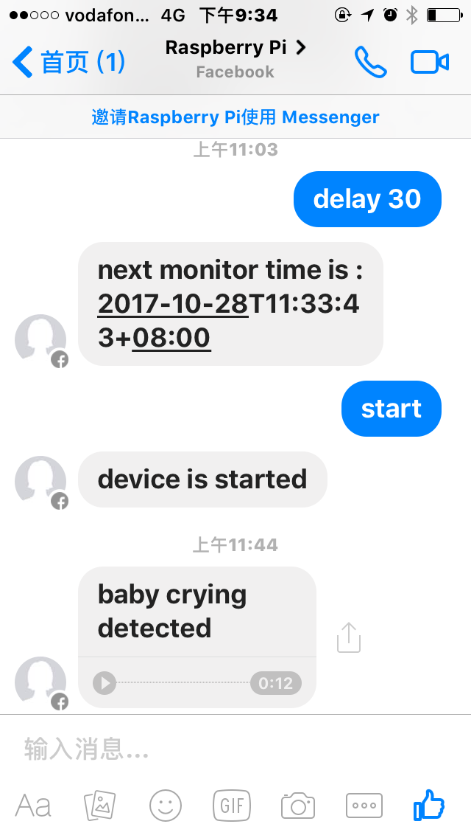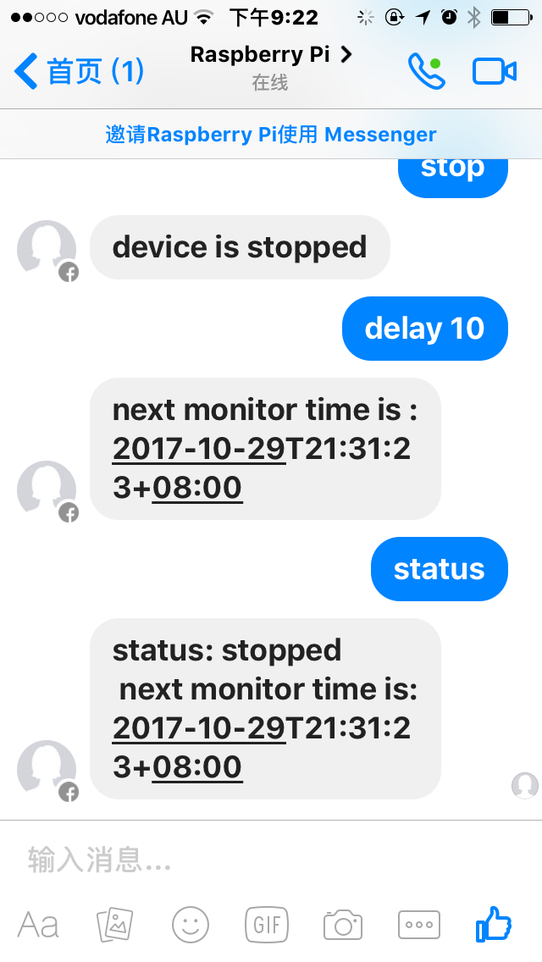
Figure 4-7. Facebook messenger application message received screenshot
Figure 4-7 shows the actual user commands and format of an alert. Users can issue "start", "stop" and "delay" commands to control the detector, and also query the detector current status by sending "status" command.

Summaries and Further Improvements
The concept of baby monitors caters to the needs of busy parents with very young babies, who want to utilize the time when the baby is asleep to do other things like grocery shopping or simply going outside to take some fresh air and want to know immediately when the baby wakes up. The baby detector is a typical IoT device that connects to Wi-Fi, gathers information from sensors, process the data locally and then send the alert to end users through a web server. In this way, a remote monitor and control are achieved.
Our device can detect baby cries and screen out other noises and sounds most of the time, but there're still quite a few false alarms and missed detections, largely the reason is we have implemented a rather simple detection mechanism, in the further some machine learning techniques can be attempted to improve the accuracy of the model. On the other hand, we can improve our product to detect other things besides baby cry and motion. To name few future enhancements and add-ons such as the room temperature and trigger an alert when the baby room's temperature changes quickly within one or two hours to remind parents to add clothes to their children for example in case of a cold wave. Also, we can sense moisture of baby's bed and inform parents when the bed is wet to change clothes for babies. Furthermore, adding a camera to our project would be useful to click a picture or send a small video clip to the parents of their baby to determine more accuracy of baby monitoring. Similarly, having an option to make a video call to a parent from a raspberry pi and parent on the receiver can make their child quiet using video call, in a case where instant care of the baby needs to be taken.

